Let 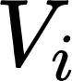 be a 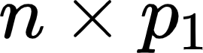 matrix of IBD probabilities between {"code":"$$n$$","aid":null,"id":"3","font":{"size":11,"family":"Arial","color":"#000000"},"backgroundColorModified":false,"type":"$$","backgroundColor":"#ffffff","ts":1653245866196,"cs":"aPo73+xWNoYAQEKy+zSZxw==","size":{"width":8,"height":6}} progeny and 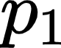 parents for bin {"aid":null,"code":"$$i$$","backgroundColor":"#ffffff","font":{"color":"#000000","family":"Arial","size":11},"backgroundColorModified":false,"id":"5","type":"$$","ts":1653245893382,"cs":"YYULO0w74irdJO3ZjYMgnA==","size":{"width":4,"height":10}} in the genome. Let 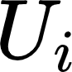 be a 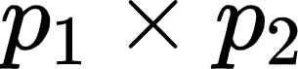 matrix of IBD probabilities between the  parents and 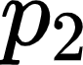 grand-parents (i.e., there are  parents of the  parents) for bin {"type":"$$","id":"9","backgroundColorModified":false,"font":{"size":11,"color":"#000000","family":"Arial"},"backgroundColor":"#ffffff","aid":null,"code":"$$i$$","ts":1653246339106,"cs":"cfY/kC+e/HpkkbZX6iofiQ==","size":{"width":4,"height":10}}. Then 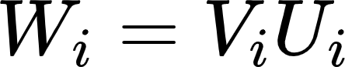 is a matrix of IBD probabilities between the {"code":"$$n$$","aid":null,"id":"3","font":{"size":11,"family":"Arial","color":"#000000"},"backgroundColorModified":false,"type":"$$","backgroundColor":"#ffffff","ts":1653245866196,"cs":"aPo73+xWNoYAQEKy+zSZxw==","size":{"width":8,"height":6}} progeny and the  grand-parents for bin {"aid":null,"code":"$$i$$","backgroundColor":"#ffffff","font":{"color":"#000000","family":"Arial","size":11},"backgroundColorModified":false,"id":"5","type":"$$","ts":1653245893382,"cs":"YYULO0w74irdJO3ZjYMgnA==","size":{"width":4,"height":10}}. In practice, if these matrices are constructed chronologically, matrix 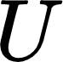 is constructed before matrix 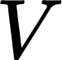. So as you progress from one generation to the next, updating the IBD probability matrix consists of left-multiplying the existing matrix with the one newly constructed for the last generation of progeny. Note that, as far as I can tell, this process has to be done bin by bin.